Custom Training

Day 6

To communicate between data storage account and data factory:

1. Shared Access Signature: Time bounded
2. Access Key: Life time access

Creation of SAS Token:

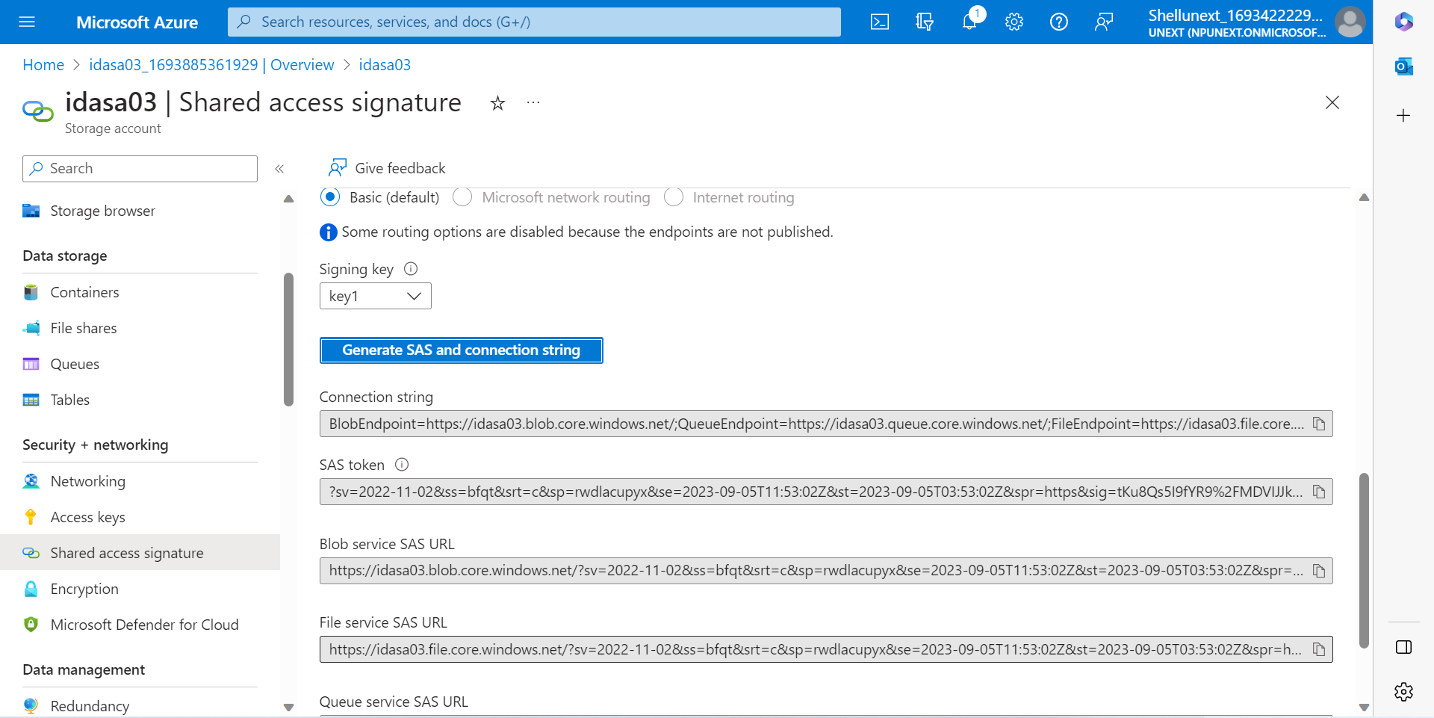

In case of data, we can’t give hard-coded passwords to give access to database. Hence we use Azure Key Vault to give a time bounded name that is mapped to a key password that can be used as a login credential.

Creation of key vault and secret:

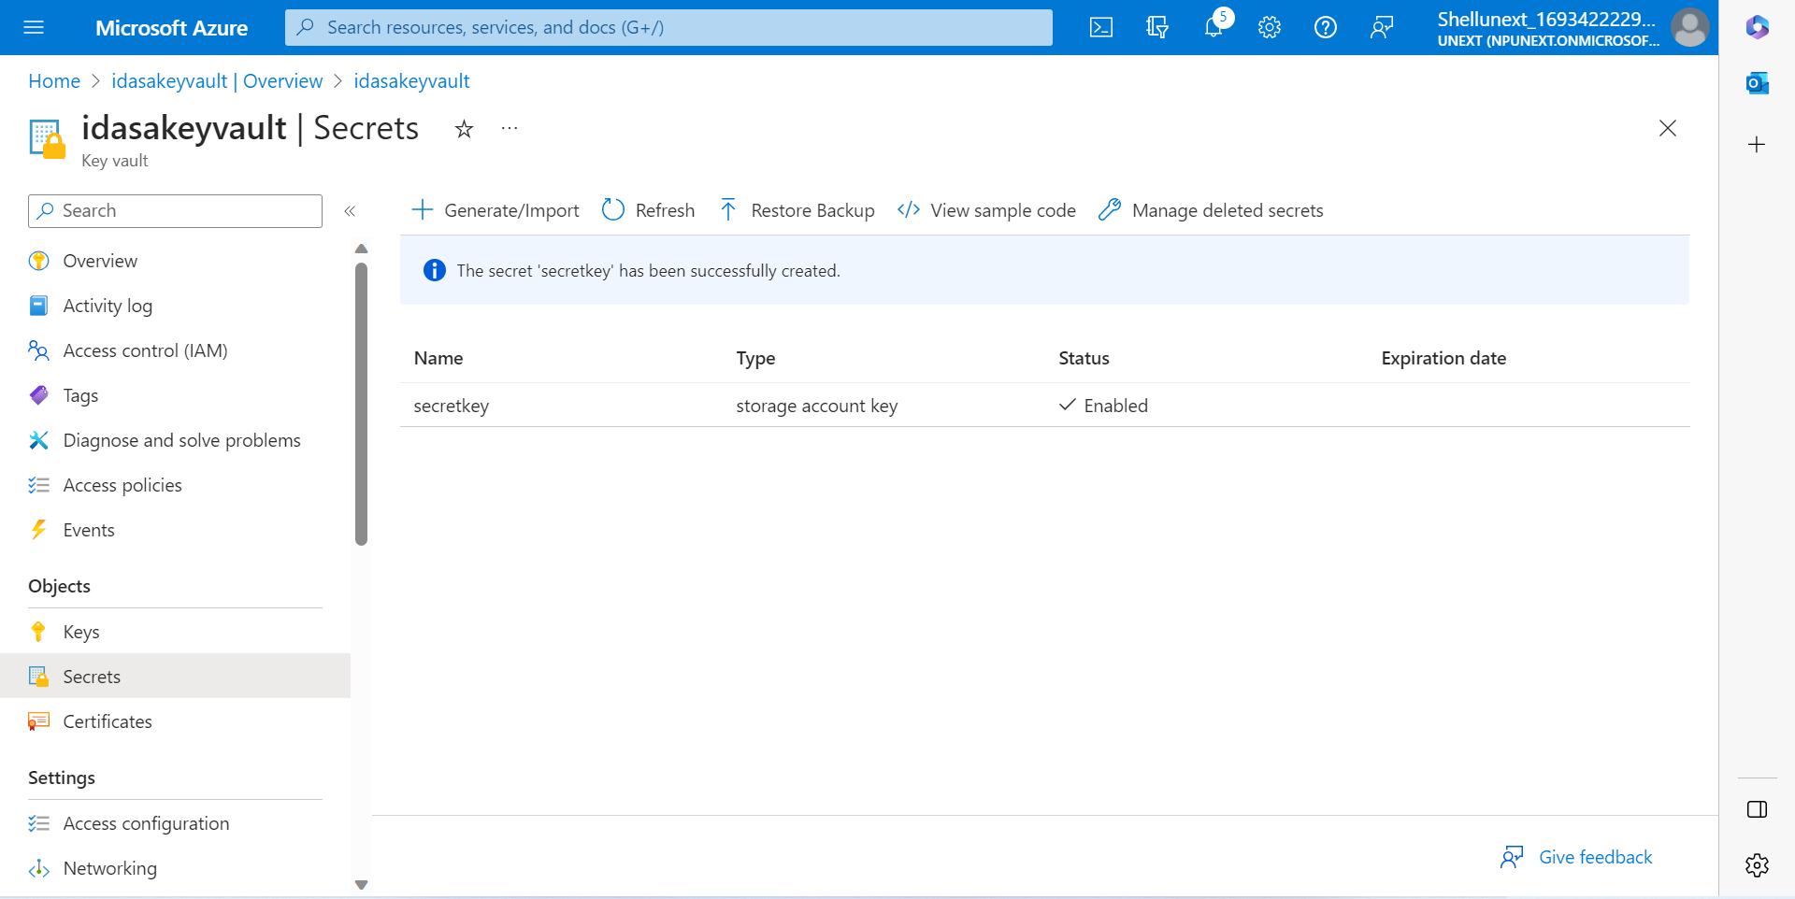

Access Control (IAM): Check your access level and assign role to other users.

**Azure Data Factory:**

Transformation: ADB

E&L: ADF, using for data flow activity

ADF Components:

1. Pipelines: Combination of one or more activities
2. Activities: Action to be carried out
3. Datasets : To access the particular file or table we create datasets.
4. Linked services : To access the particular path or database we create linked service.
5. Integration runtime: To communicate to any source or destination, we create a connection. Gives access to a higher level.
6. Triggers
7. Data flow

ELT: Advantage is we need not extract data from the source each and every time.

ETL: We transform all the data that is extracted.

IR:

1. Azure Auto Resolved: If we have any cloud based storage.
2. Self Hosted: If we have any on-premises or local storage and want to connect to it.
3. Azure SSIS: If any existing SSIS package and want to run that in Azure SSIS.

Creation of Azure Data Factory:

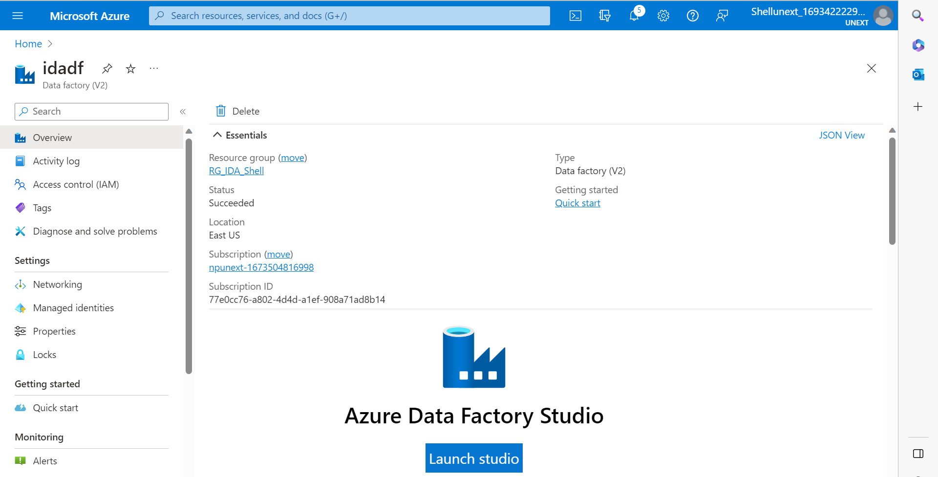

Creation of Integration Runtime:

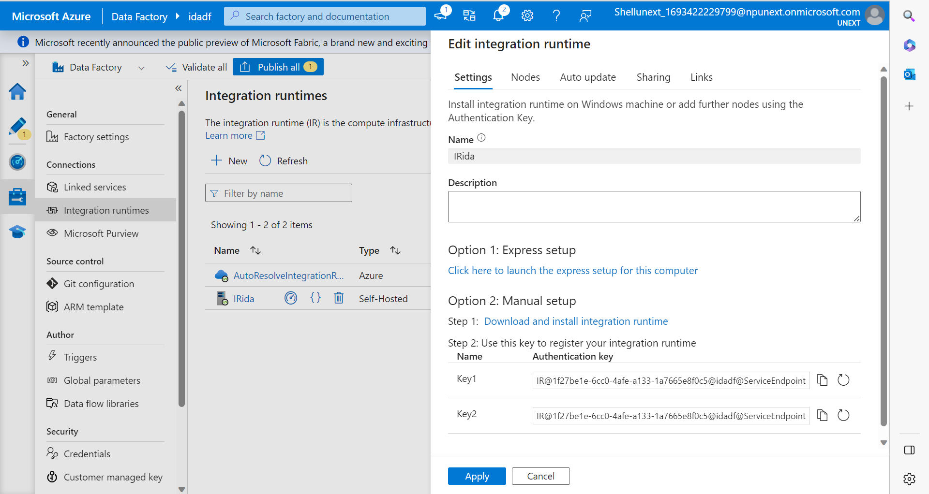

Creation of Linked Service:

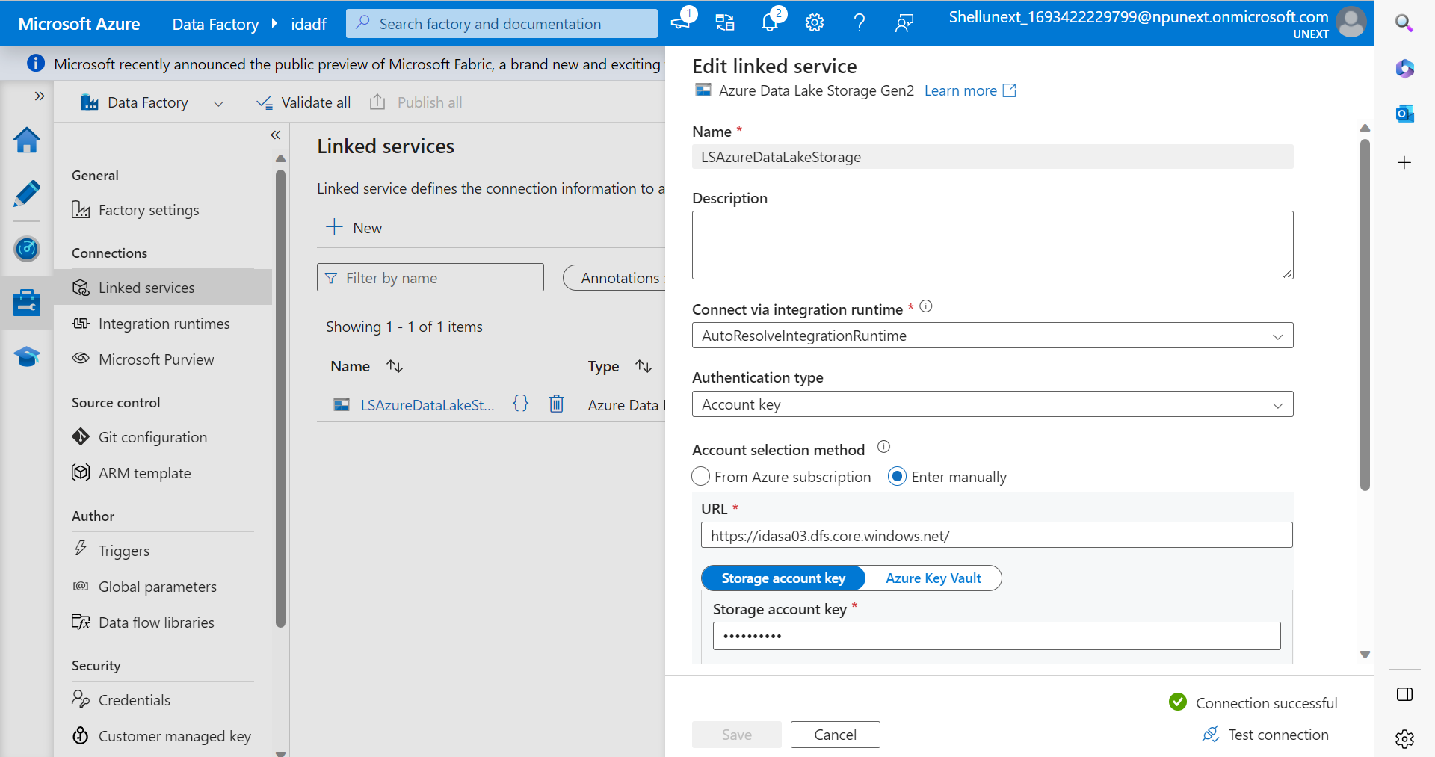

Creation of Dataset:

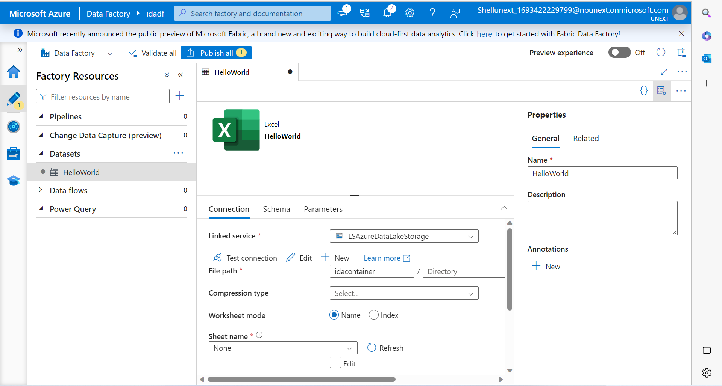

Parameterized dataset and linked service: Each time it will run, we can give the name of dataset and linked service so that the same pipeline can be used for different parameters.

Pipeline: Overview of pipeline and simple copying of data from one source to another with and without parameterization.